**Assignment**

Build, Track, Package, Deploy and Monitor an ML Model using MLOps Best Practices with California Housing Dataset

**Subject**

MLOps – AIMLCZG523

**Group**

Group-16

**Contributors**

Anup Jindal - 2023ac05472 – 100%

Yogesh Chaturvedi - 2023ac05167 – 100%

Debasish Acharya - 2023ac05417 - 100%

Anit Nair - 2023ac05503 – 100%

# Project Content Details

### **Github Repo**

[**https://github.com/nairanit25/MTechAssignments**](https://github.com/nairanit25/MTechAssignments)

### **DockerHub Repo**

[**https://hub.docker.com/repository/docker/nairanit25/housing-mlops/general**](https://hub.docker.com/repository/docker/nairanit25/housing-mlops/general)

<https://hub.docker.com/r/nairanit25/housing-mlops>

### **End-To-End Project Demo Video Link**

<https://drive.google.com/drive/folders/18w9lkrFTBUeahCCMlFVG1FHTRQaePcn8?usp=sharing>

Note: The video captures complete end-to-end, hence spans 20 minutes. This summary documents captures each activity screenshot demonstrated in the video.

## Architecture Overview (Part-6)

The below diagram represents the MLOps design for housing price prediction assignment. This assignment implements a comprehensive ML lifecycle for housing price prediction, incorporating data versioning, model training, experiment tracking, model registration through MLFlow, deployment, and monitoring.

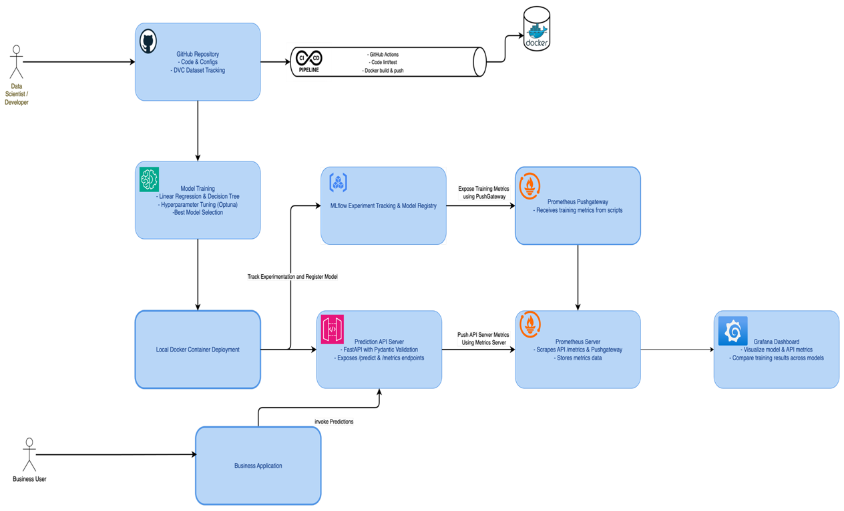

## Architecture Summary (Part-6)

### Data and Code Versioning

Source code and configurations are managed in a **GitHub repository** to track all changes. The California Housing dataset is versioned using **DVC**, ensuring consistent reproducibility of data and experiments. The project maintains a clear directory structure to separate code, data, and models.

### Model Development and Tracking

Two models — **Linear Regression** and **Decision Tree** — are trained using Python scripts. Hyperparameter tuning is automated with **Optuna**. **ydata_profiling** was used for basic data exploration and validation. All experiments, parameters, and evaluation metrics are logged to **MLflow Tracking Server**. The best model is selected and registered in the **MLflow Model Registry** for deployment.

Model Retraining on dataset change is retriggered using a background watcher.

### API and Containerization

A prediction API is built using **FastAPI** that accepts JSON inputs and returns predictions. Input validation is handled via **Pydantic**. The API exposes Prometheus-compatible /metrics endpoints. The entire service is containerized using **Docker**, simplifying deployment across environments.

### CI/CD Pipeline

**GitHub Actions** automate code testing, Docker image building, and pushing to Docker Hub. Deployment scripts enable running containers locally or on cloud infrastructure. This pipeline guarantees automated, repeatable, and consistent deployments.

### Logging and Monitoring

Incoming prediction requests and responses are logged for audit and debugging. Custom metrics (training RMSE, R²; API request rates, latencies) are captured via the **Prometheus client**. Training metrics are pushed to a **Prometheus Pushgateway** from local training scripts. Prometheus scrapes both the API and Pushgateway endpoints. Visualization and alerting are set up using **Grafana dashboards** that compare model metrics across training runs.

#### Grafana Dashboard captures following metrics

* **Prediction Count**
* **Prediction Request Latency (p95)**
* **CPU Usage**
* **Memory Usage**
* **Request Rate**
* **Model RMSE Comparison**
* **Model R2 Comparison**

This architecture ensures an end-to-end robust ML system incorporating version control, experiment tracking, containerized deployment, continuous integration, and real-time monitoring—enabling reproducibility, maintainability, and scalability.

## Project Execution: End-To-End Steps

### Git Repo Setup/Repository Structure (Part-1)

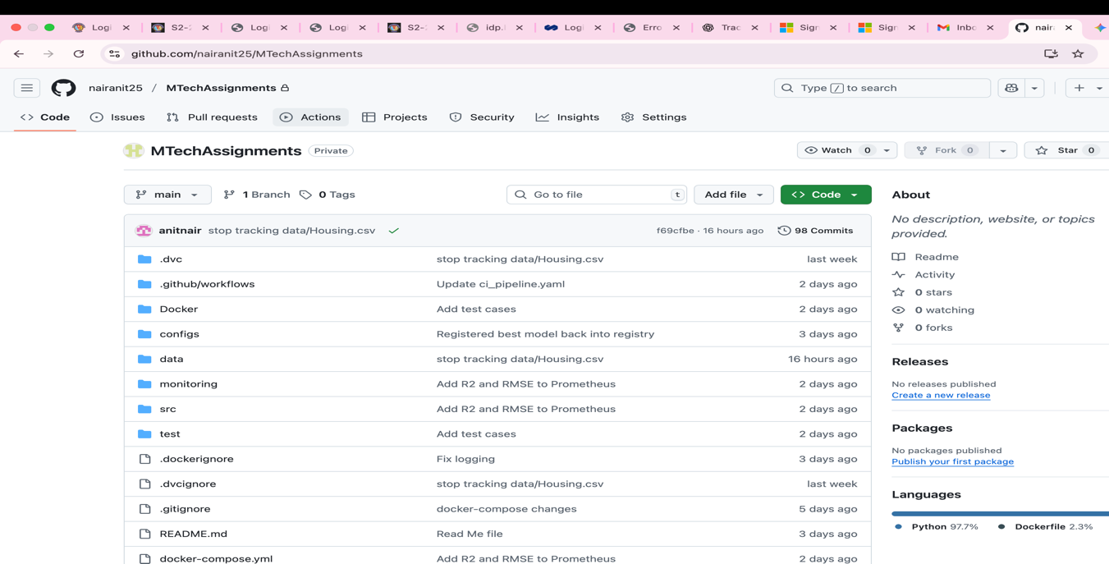

### Code pulled from Git and Data files pulled from DVC (Part-1)

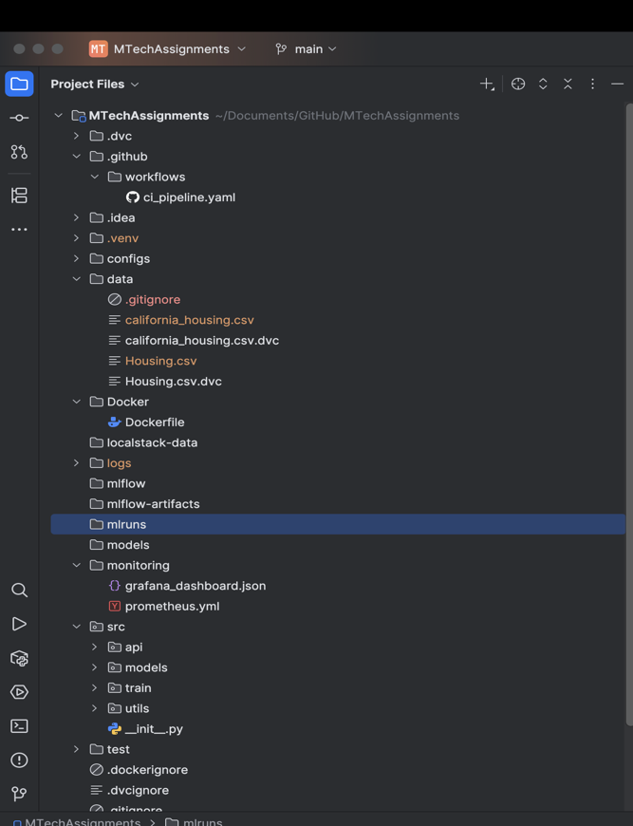

### Data versioning using DVC (Part-1)

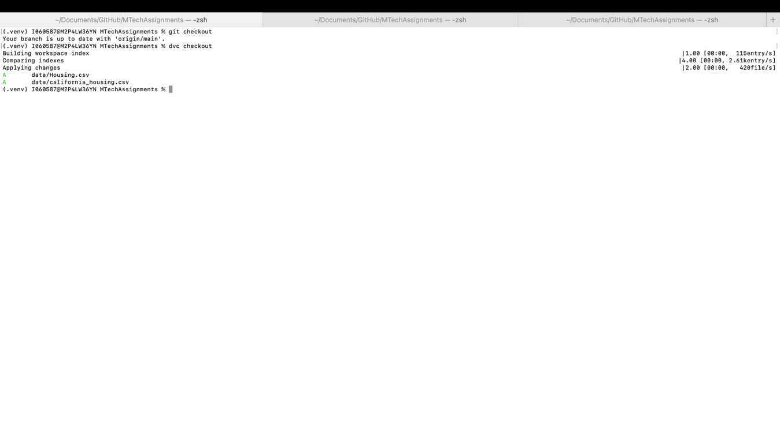

Basic EDA using YData Profiling (Part-1)

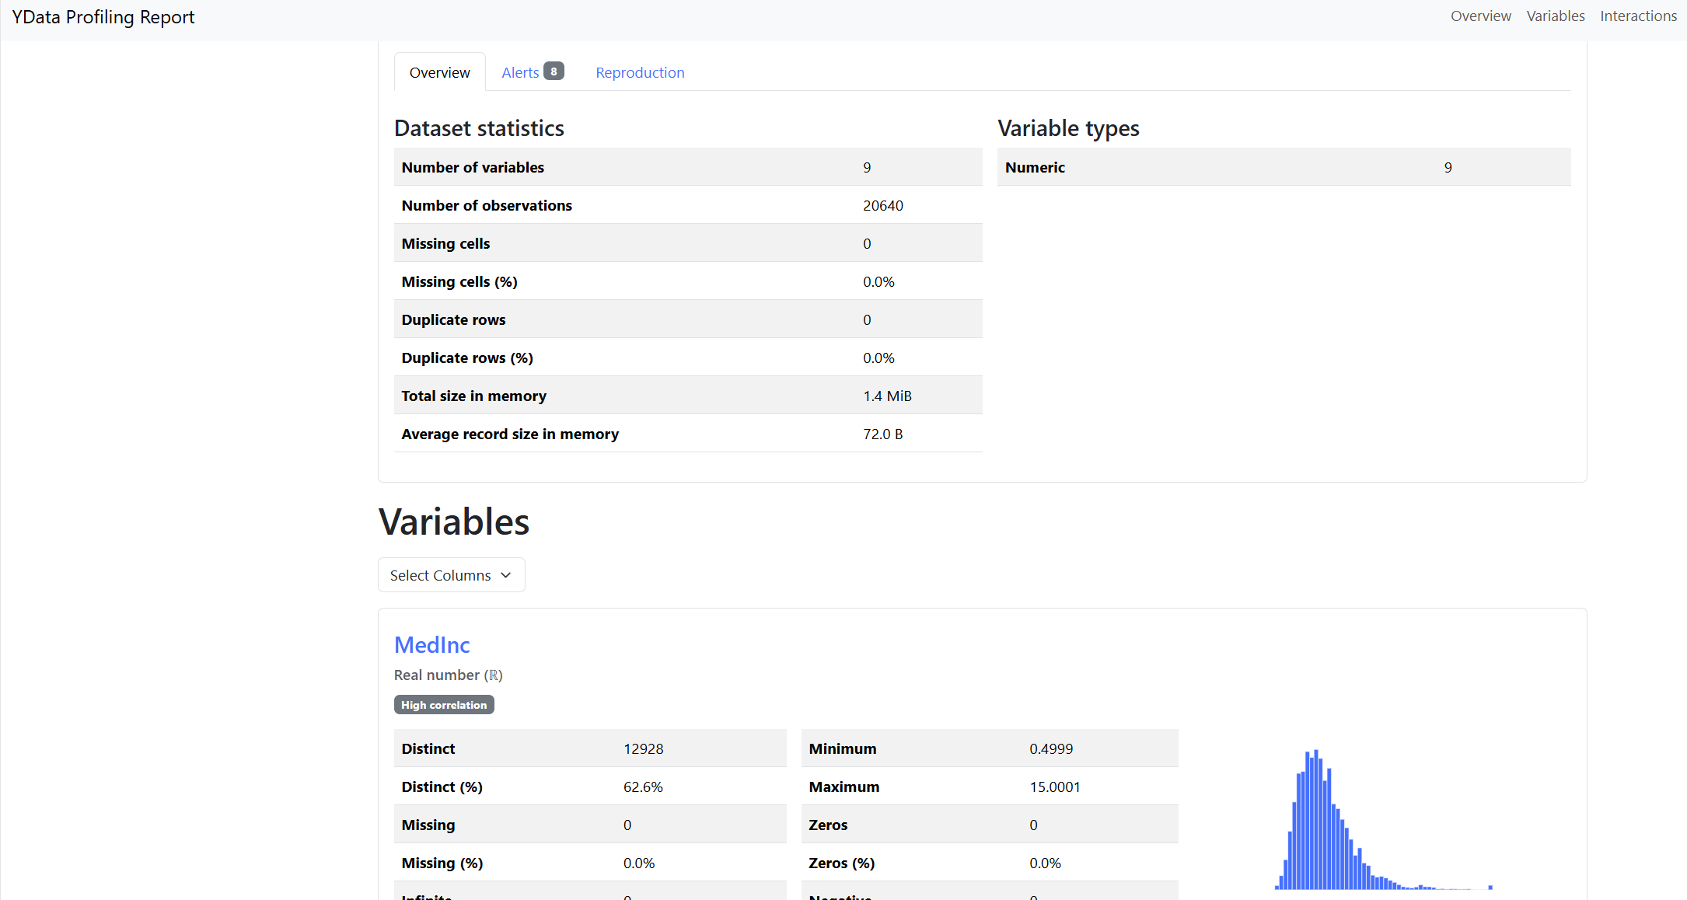

### DockerHub Repository (Part-4 CI/CD)

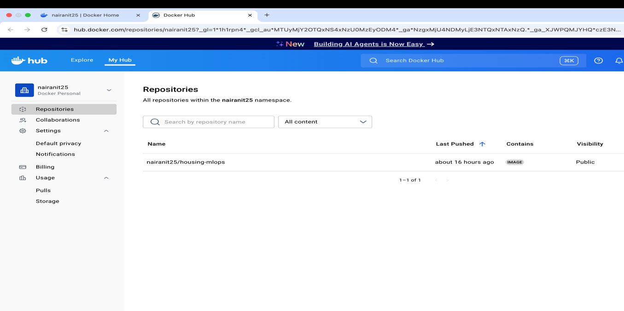

### Commit to trigger Github Actions (Part-4 CI/CD)

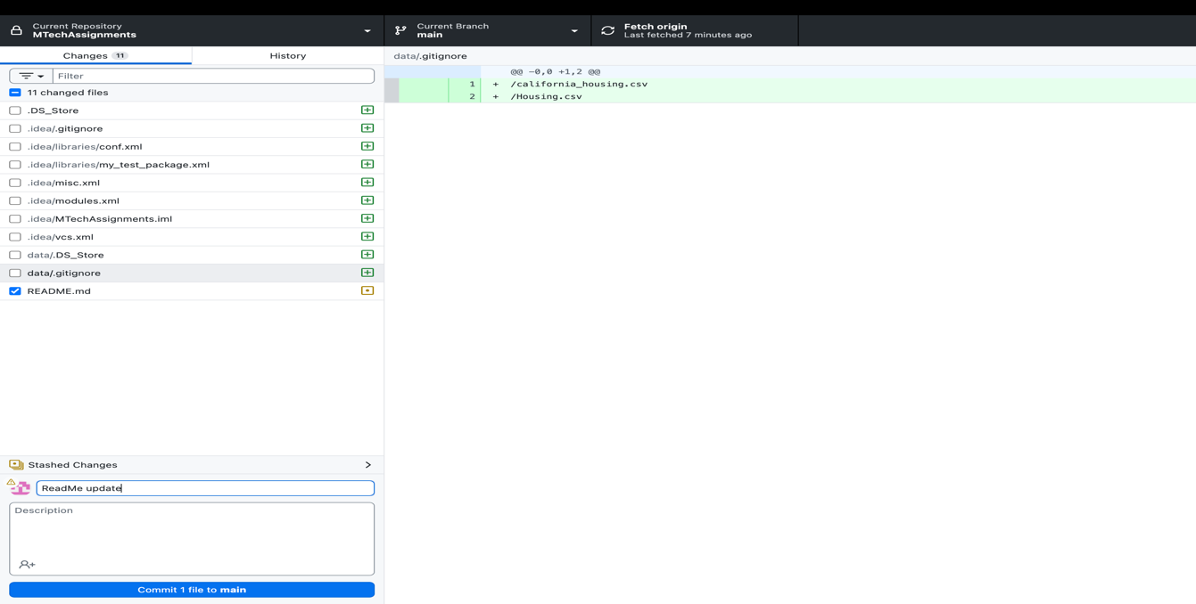

### Github Actions Triggered for commit (Part-4 CI/CD)

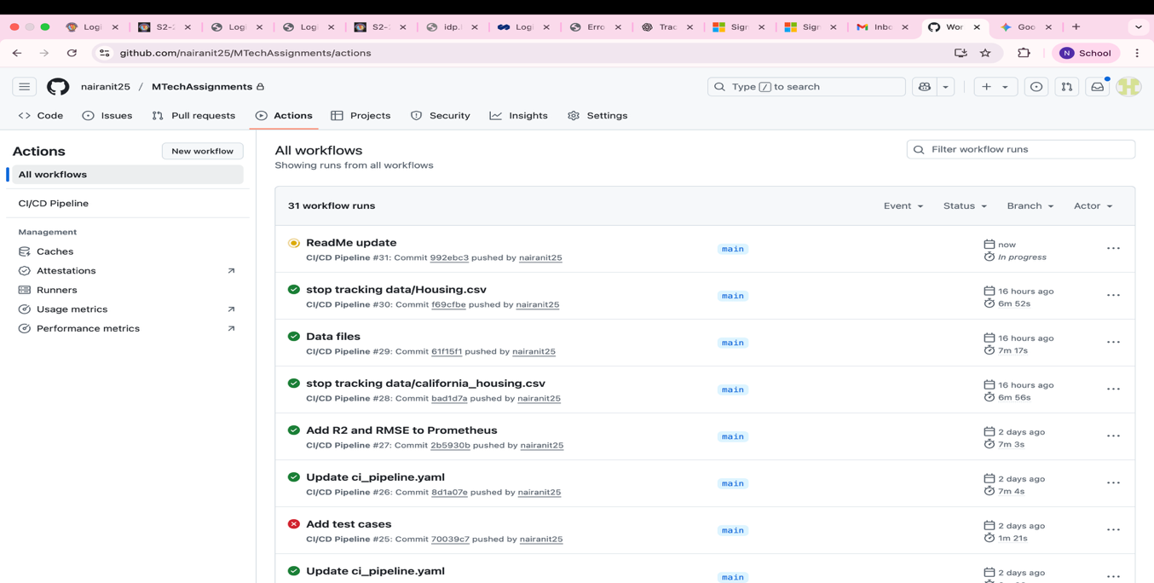

### Continuous Build and Test (Part-4 CI/CD)

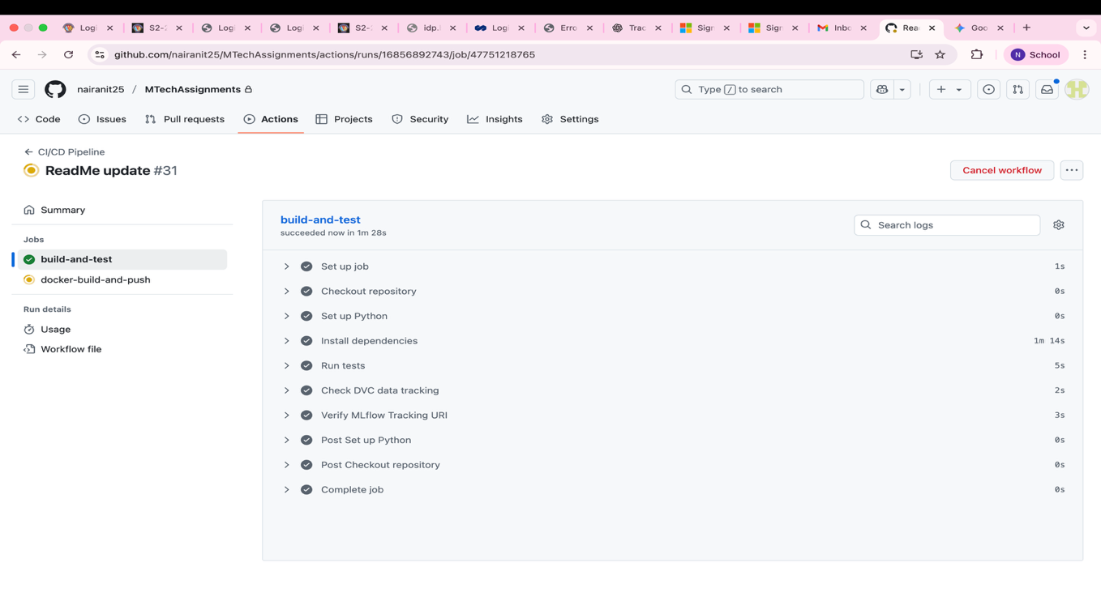

### Continuous Test (Part-4 CI/CD)

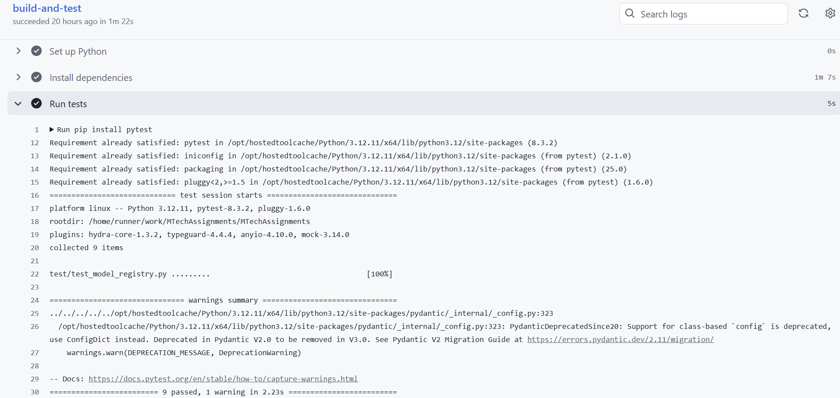

### Continuous Deployment: Docker-Build and Push (Part-4 CI/CD)

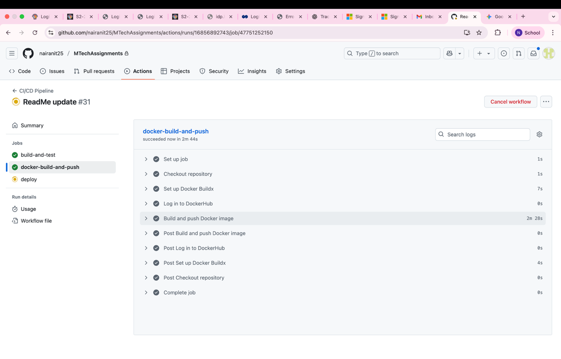

### Continuous Deployment: Deploy (Part-4 CI/CD)

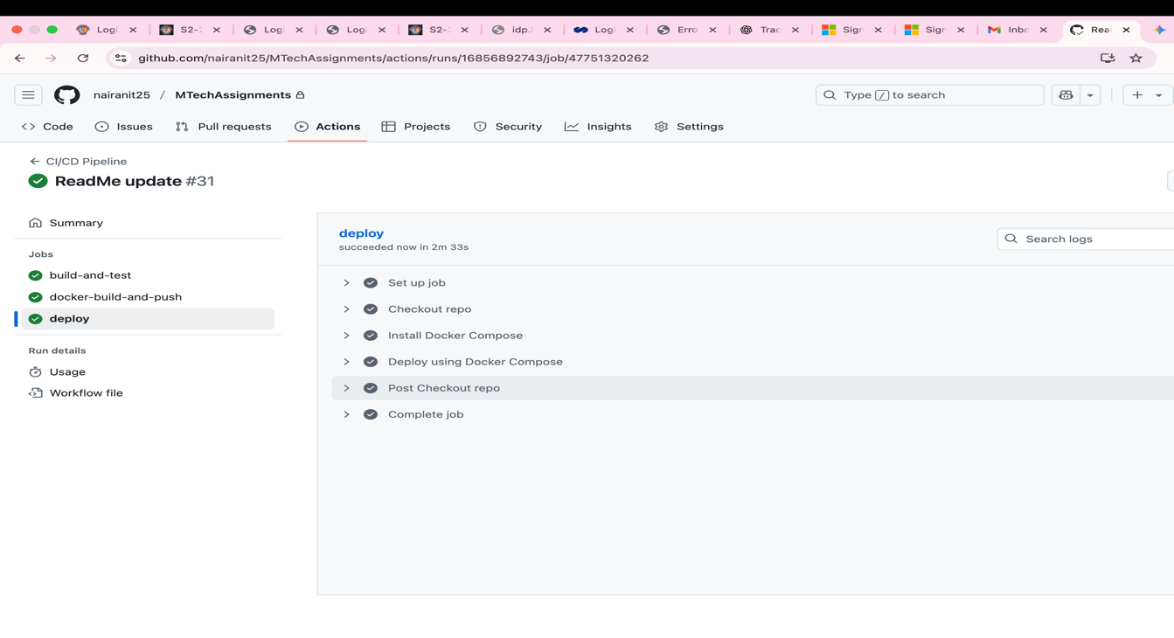

### Github Actions: Successfully triggered the pipeline and completed for the commit (Part-4 CI/CD)

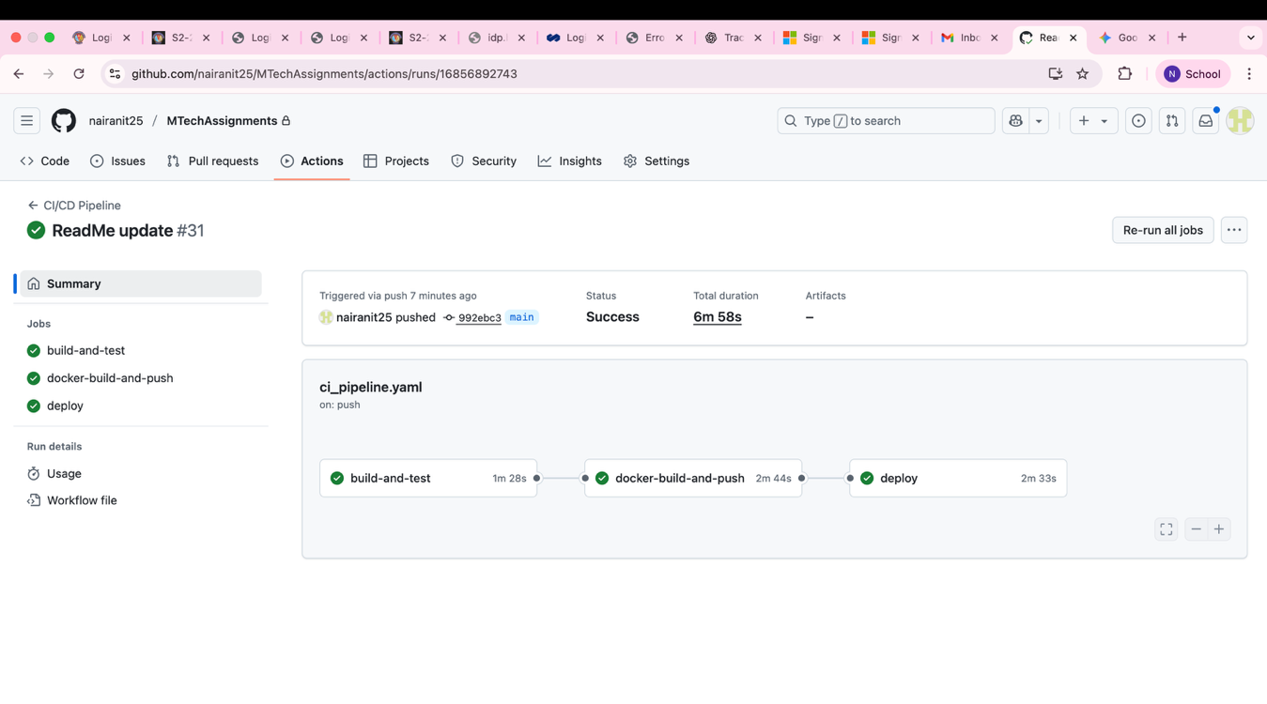

### Docker Image: Latest Image pushed to Dockerhub (Part-4 CI/CD)

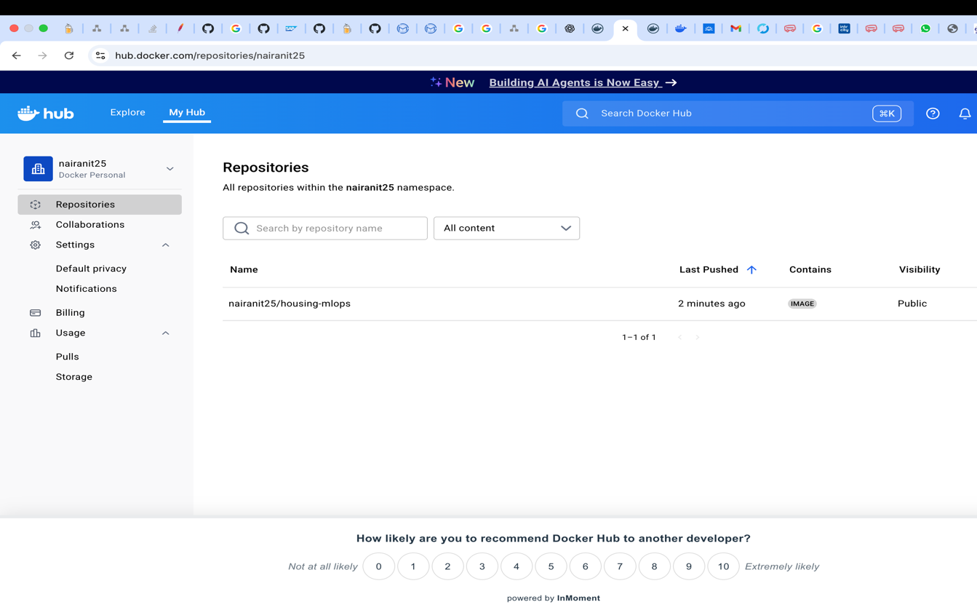

### Continuous Deployment: Triger Deploy to Local Docker (Part-4 CI/CD)

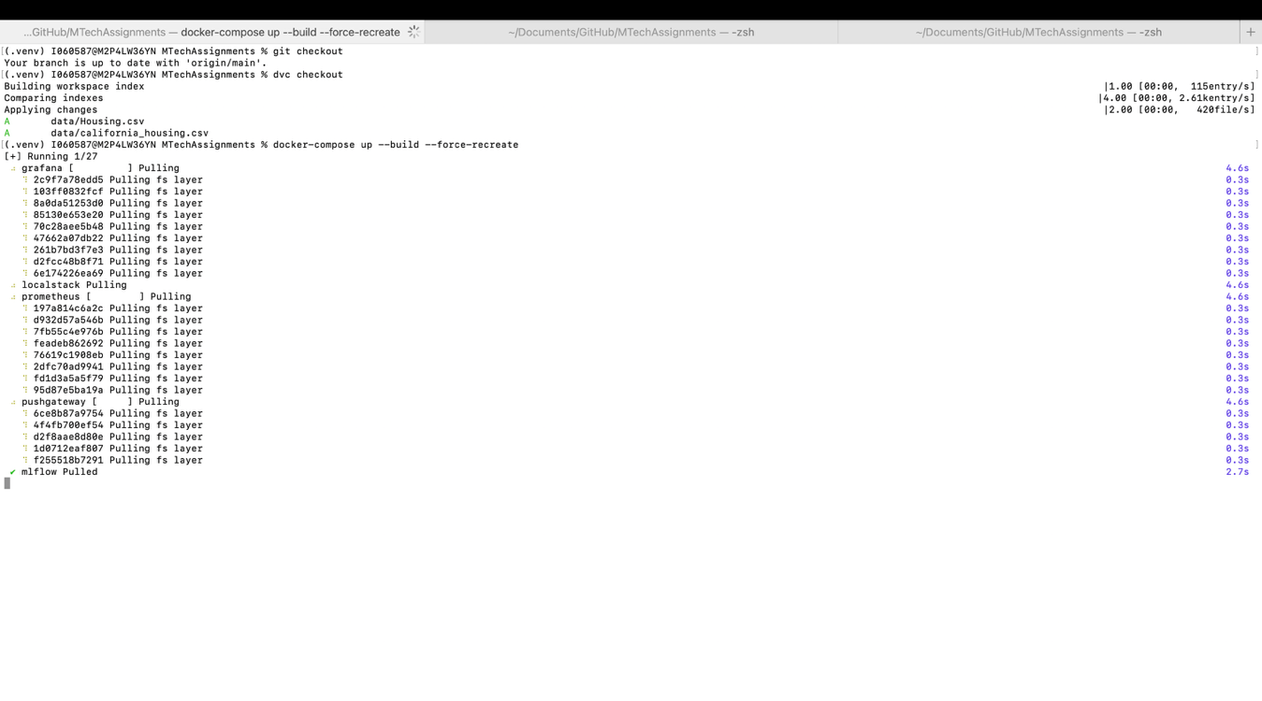

### Deployment Status: All required services and the API server deployed to Local Docker (Part-4 CI/CD)

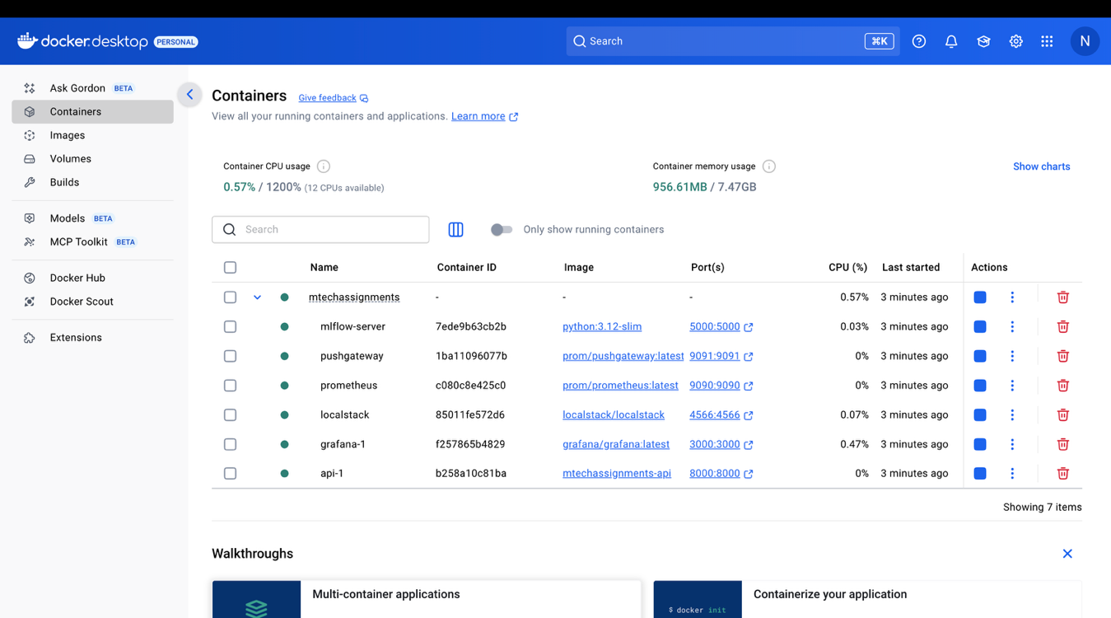

### Application Status: API Server up with no model registered yet! (part-4)

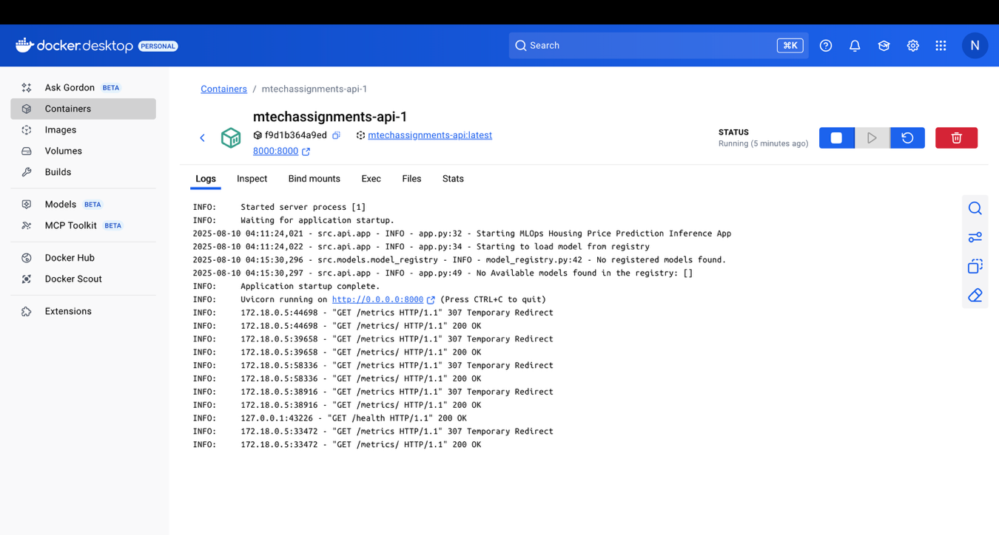

### Optuna Hyperparameter Tuning Report (Part 2)

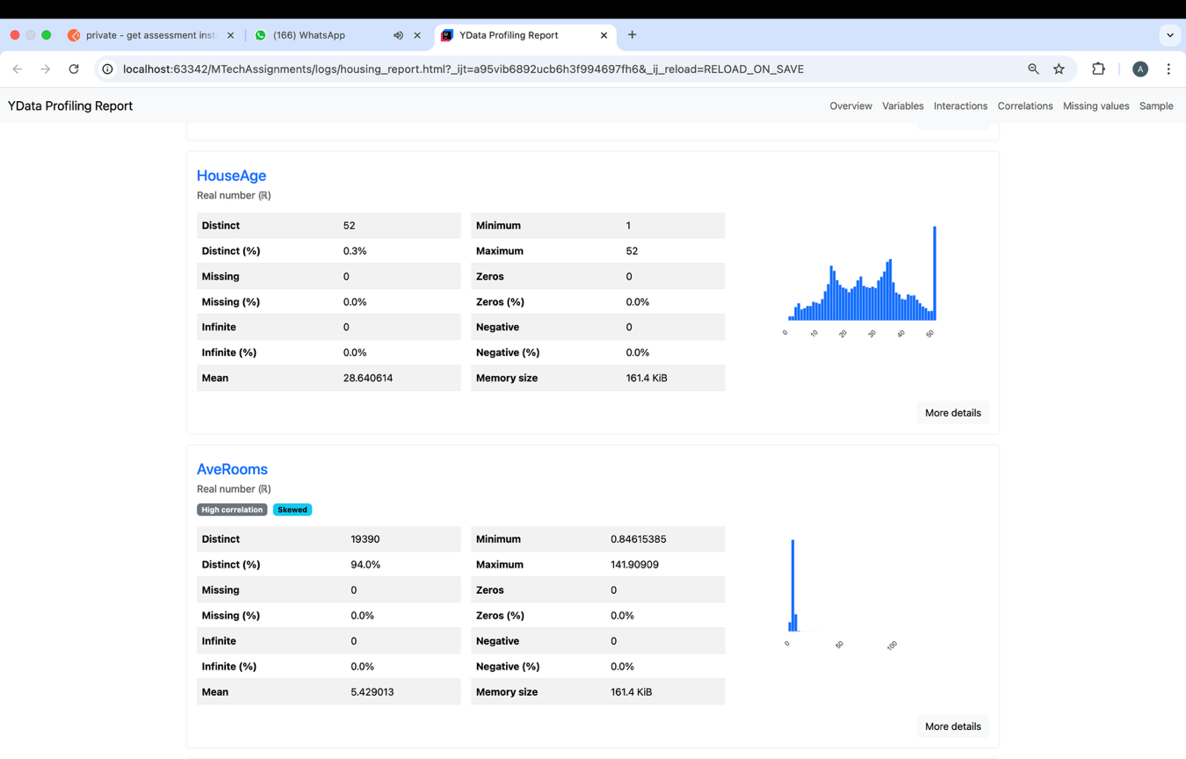

MLFlow Experiments Recording (Part-2)

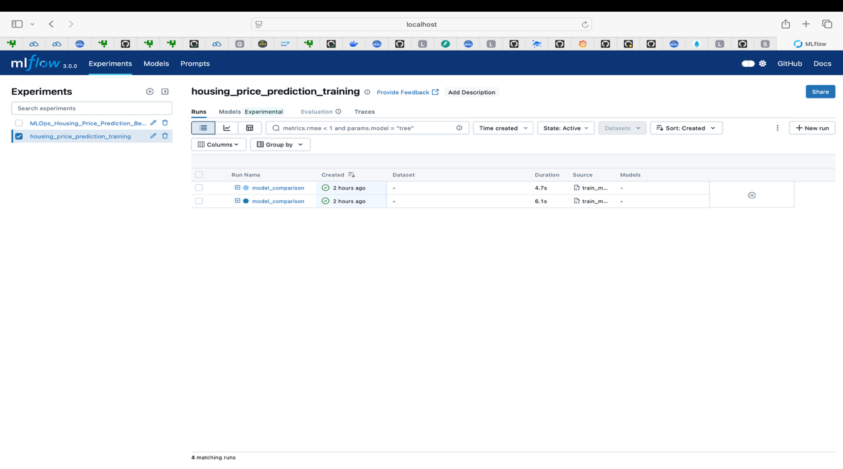

MLFlow Best Model in Registry (Part-2)

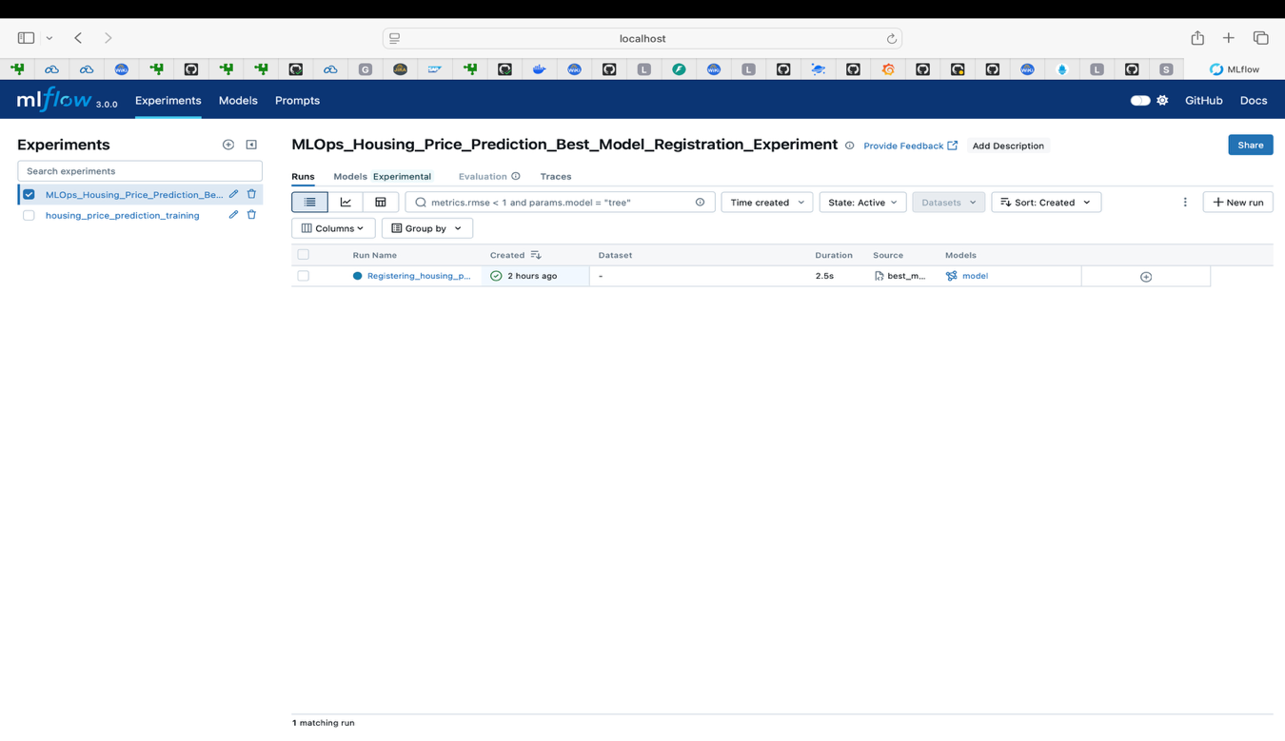

### Train Linear Regression Model – California Housing (Part-2)

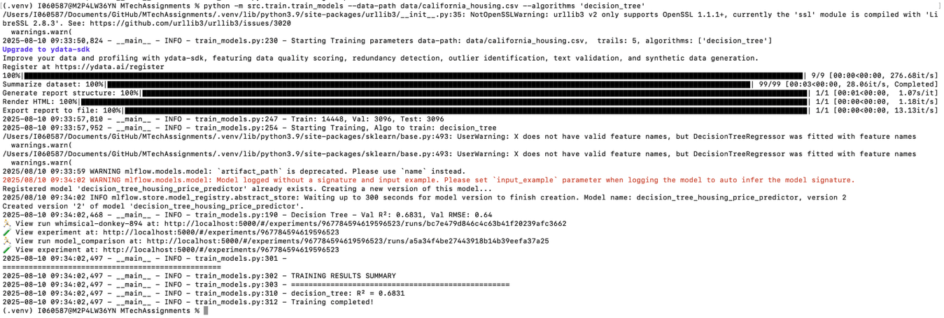

### Train Decision Tree Model – California Housing (Part-2)

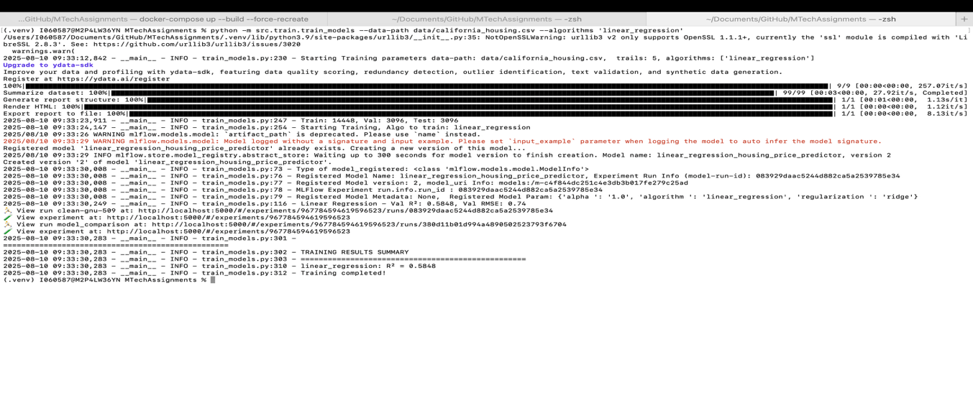

### Register best performing Model to MLFlow Model Registry (part-2)

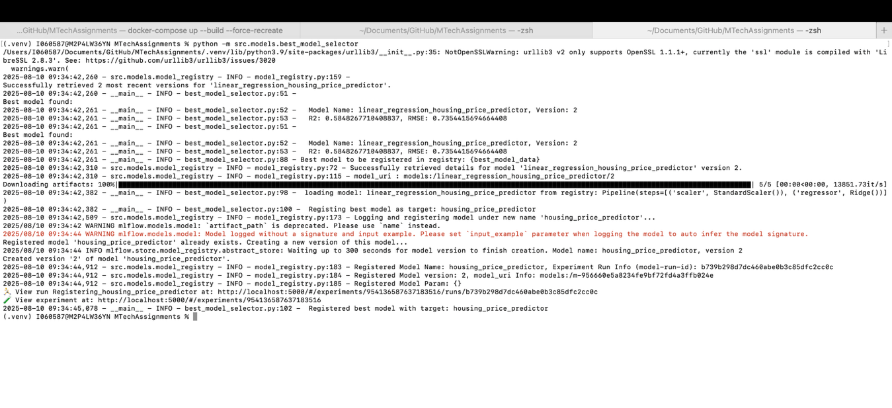

### Successful Training Retrigger on dataset Change (Bonus Assignment)

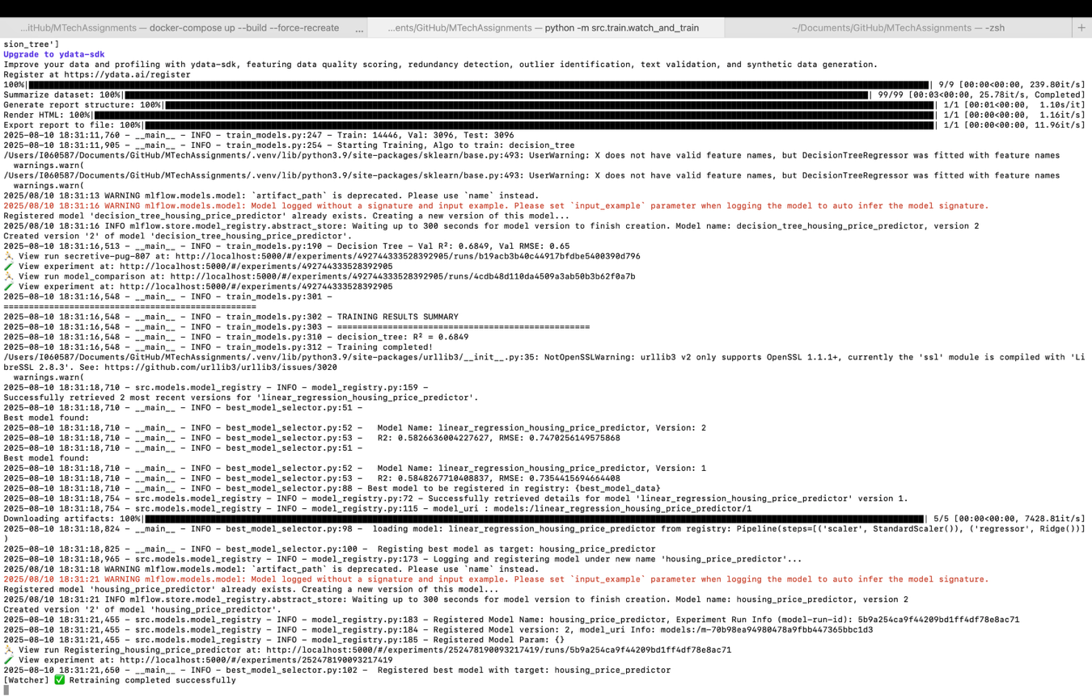

Containerized API Service on best performing registered model for predictions (Part-3)

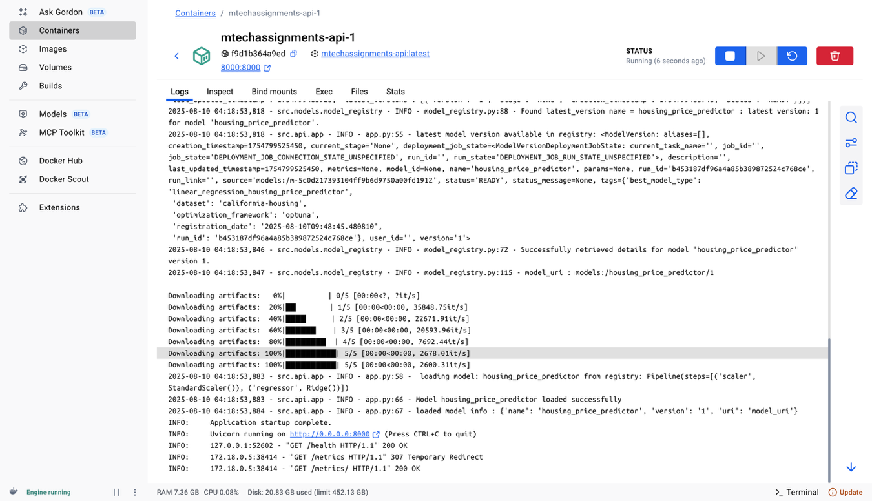

Swagger APIs Published (Part-3)

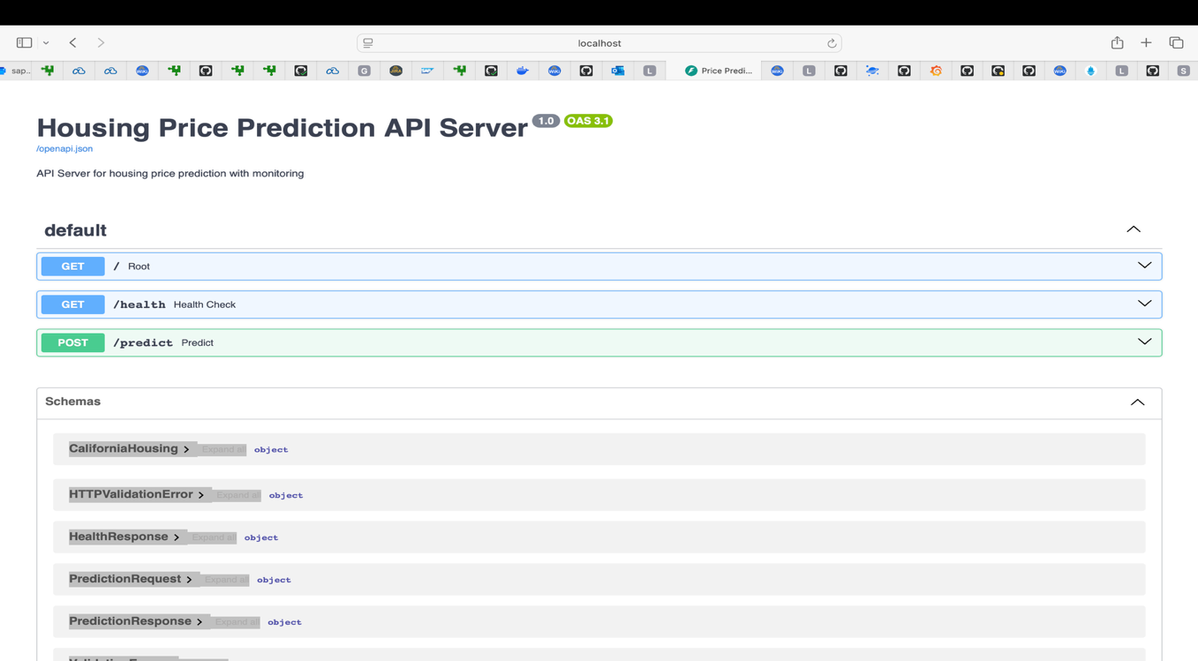

### Invoke Prediction (Part-3)

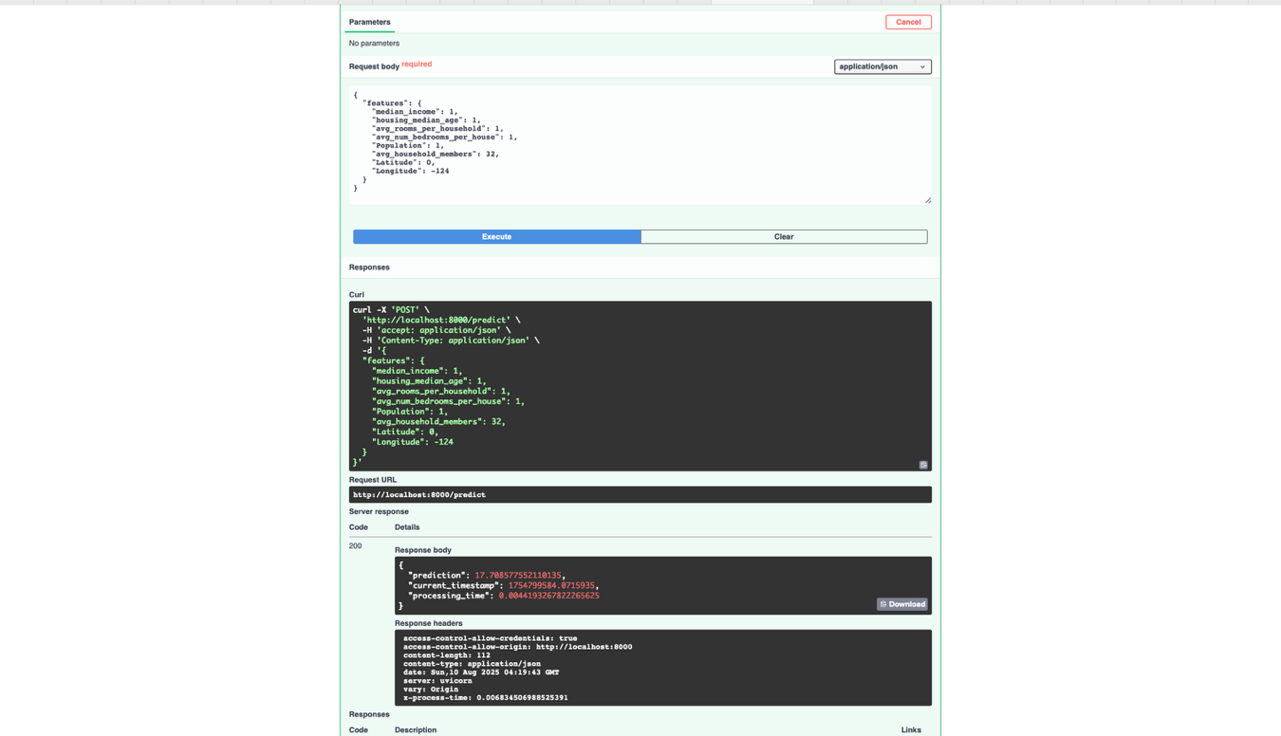

### File Based Logging: Model Logging (Part-5)

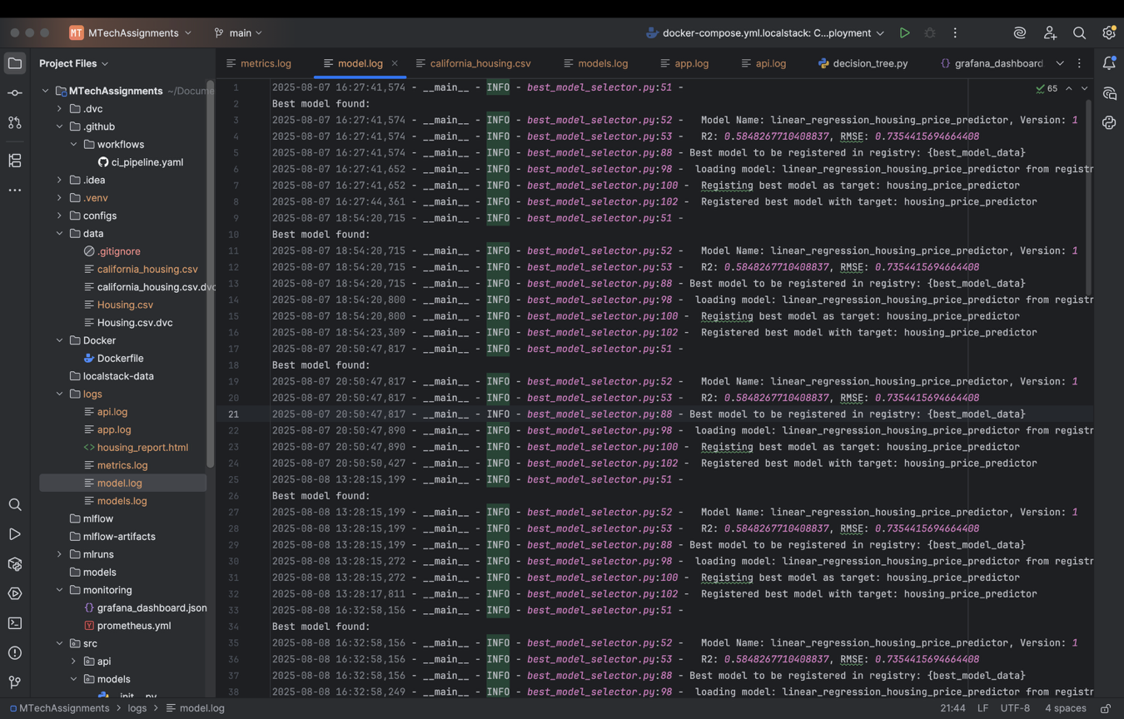

### File Based Logging: Training Logs (Part-5)

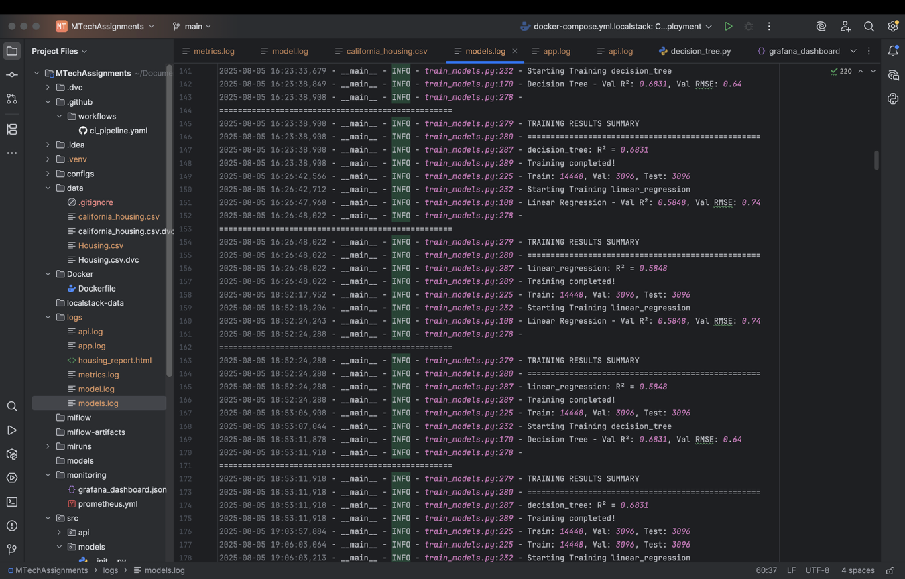

### API server log metrics exposed through /metrics API (part-5)

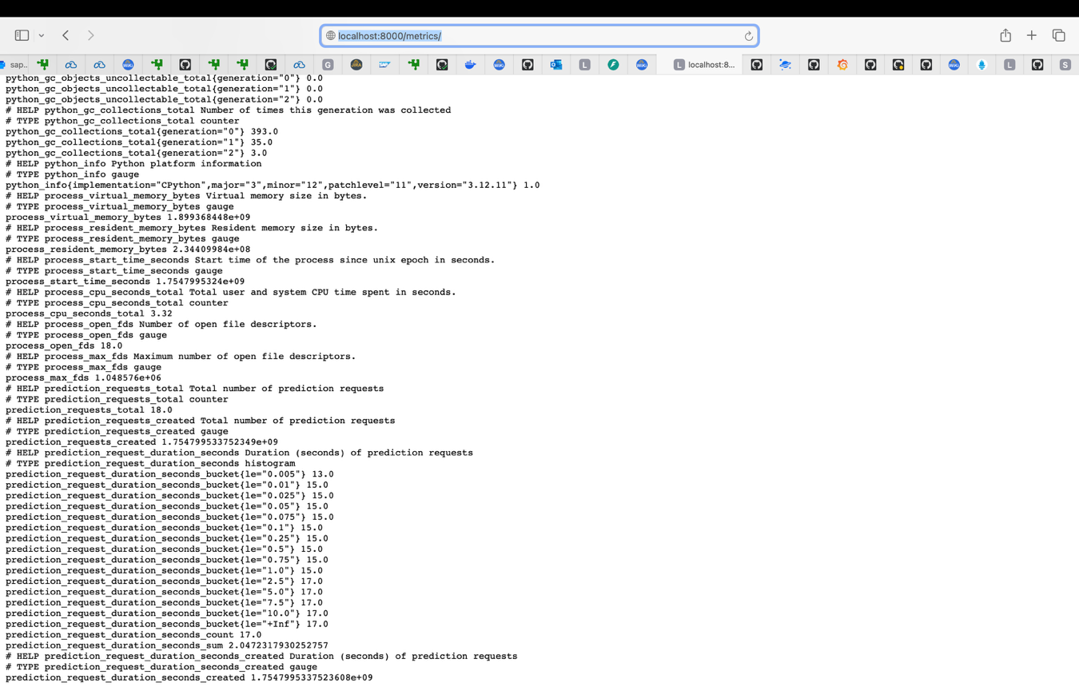

### Model Training metrics exposed through Pushgateway (Bonus Assignment)

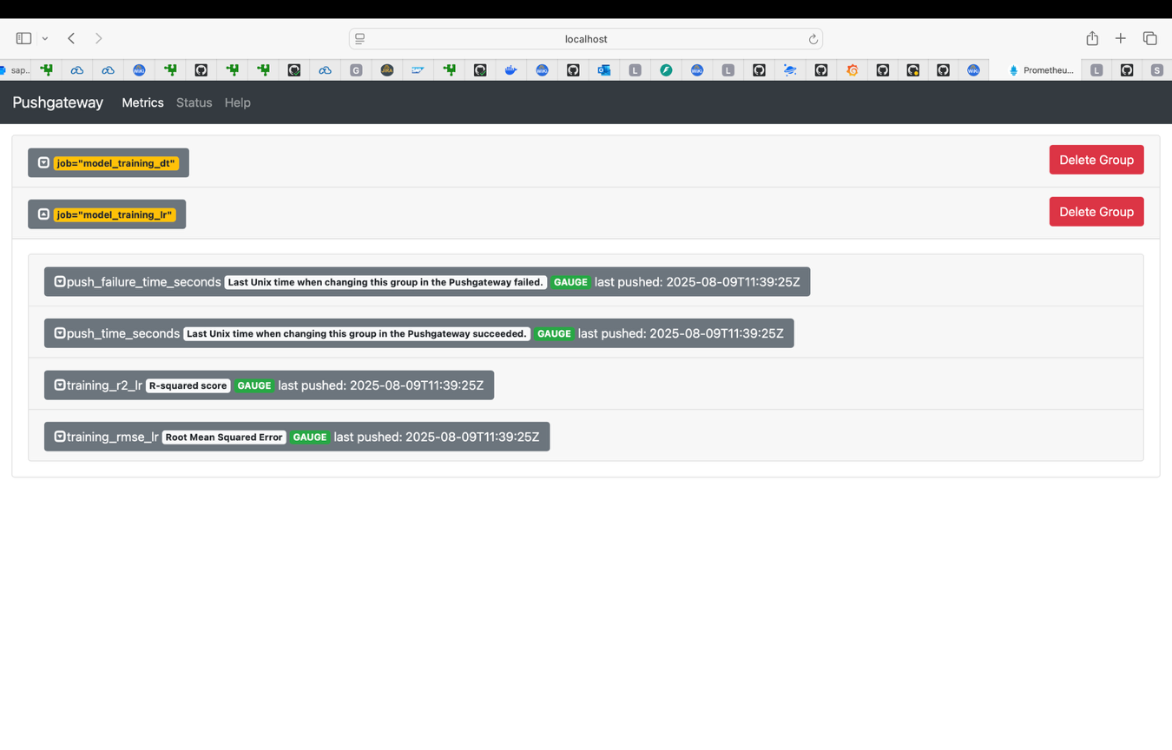

### Prometheus Dashboard Query for Decision Tree – RMSE (Bonus Assignment)

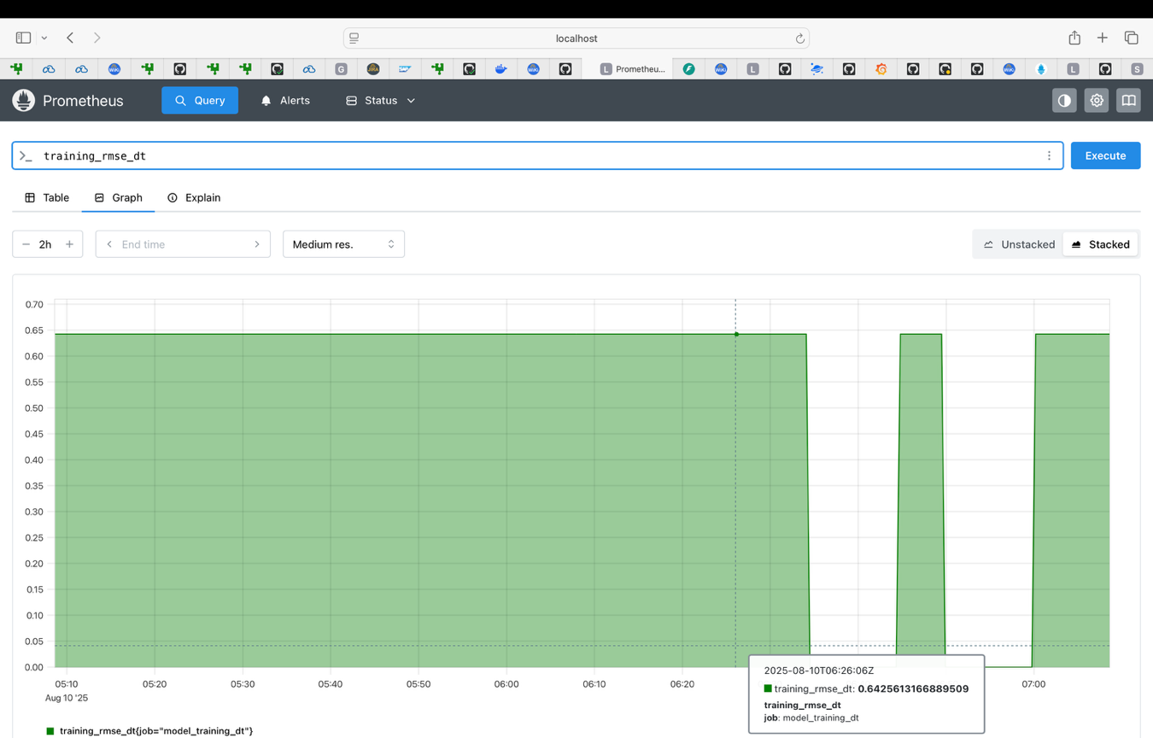

### Prometheus Dashboard Query for Decision Tree – R2 (Bonus Assignment)

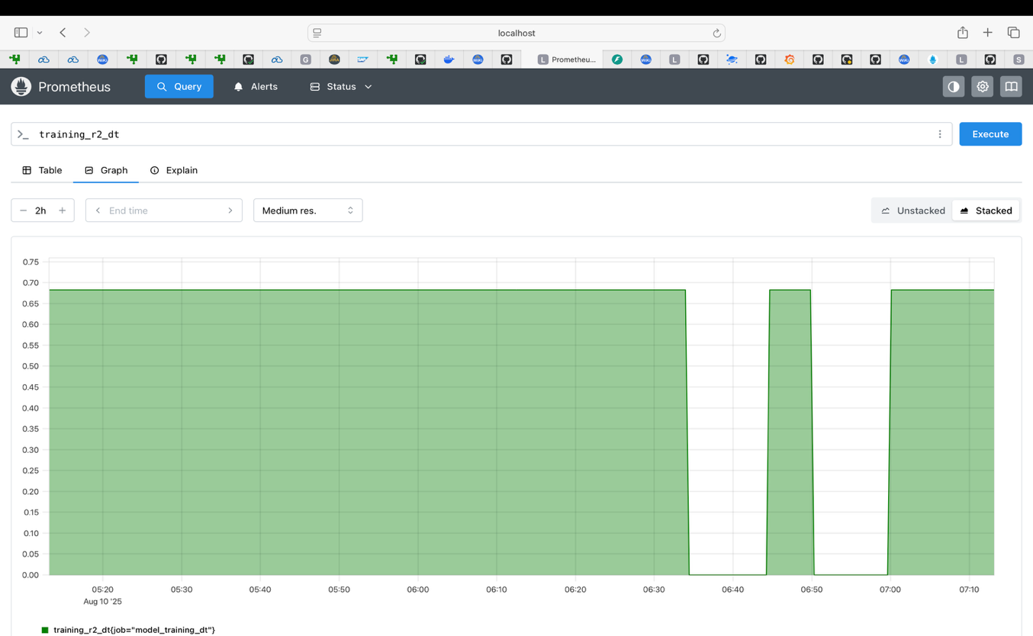

### Prometheus Dashboard Query for Linear Regression – RMSE (Bonus Assignment)

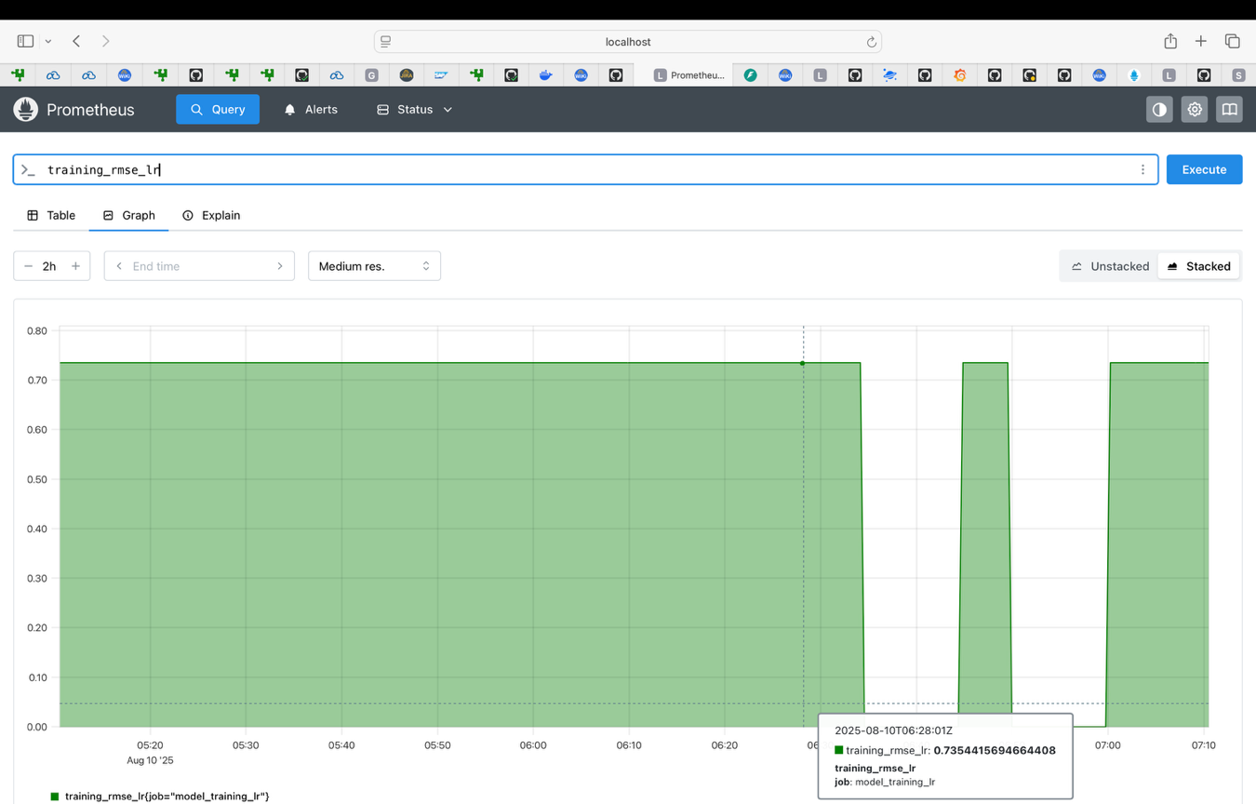

### Prometheus Dashboard Query for Linear Regression – R2 (Bonus Assignment)

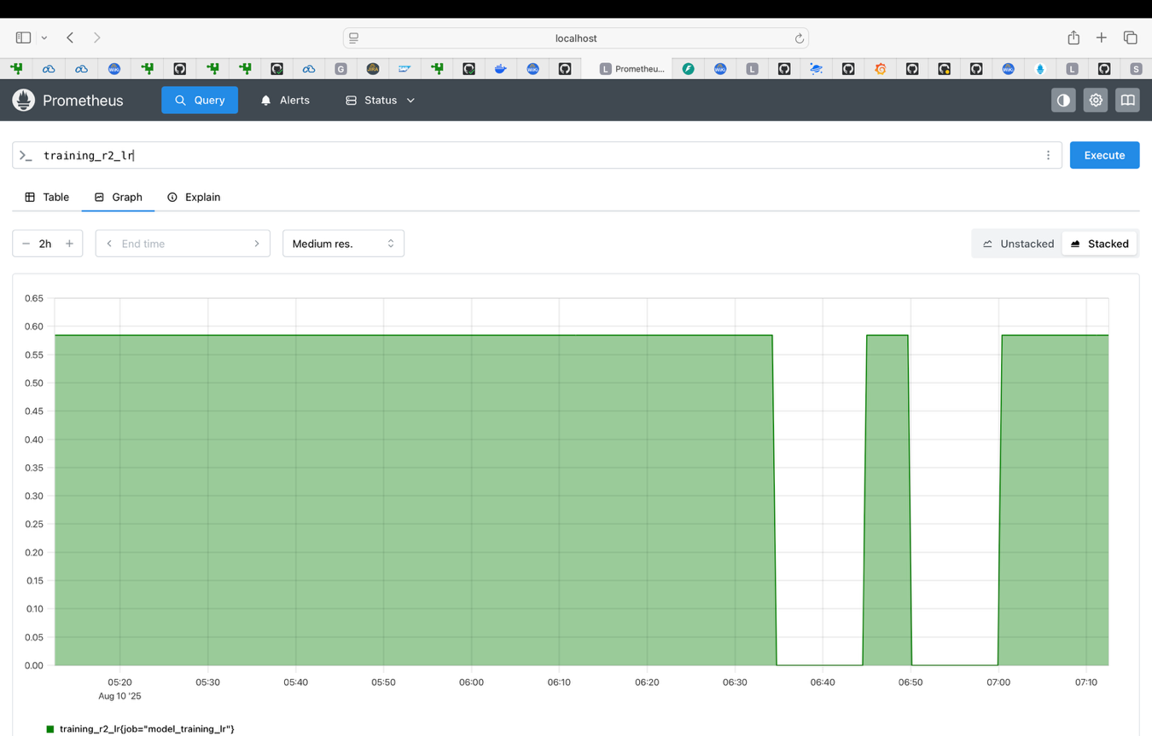

### Grafana Dashboard for Request and Training Metrics (Bonus Assignment)

